News from Partners

Nano Terra

Work on Peripheral Nerve Injury Repair and Regeneration Program
CAMBRIDGE, Mass., June 15, 2018
Nano Terra today announced that it is continuing development of its peripheral nerve injury repair and regeneration (PNIR&R) technology. Originally funded through a Phase I SBIR awarded by the US Army in 2014 that was renewed for a Phase II program in 2015, this additional effort on the PNIR&R program will further advance the ability to improve the lives of Warfighters injured in combat. The technology being developed through this program in close collaboration with Prof. Kevin Eggan of Harvard University and Prof. David Neivandt of the University of Maine has shown promise in treating peripheral nerve injury.
​
“We are very excited to have the opportunity to continue working on the PNIR&R program,” said Dr. Paul Sweetnam, EVP of Life Sciences at Nano Terra. “Once fully developed, our technology will be a huge step forward in peripheral nerve repair and regeneration for the Warfighter and beyond.”

PHL Burg
Neural networks diagnose and forecast infarctions | Scientists at Perm State University (PSNRU) have developed an intelligent cardiovascular diseases diagnostic and prognostication system built on advanced artificial neural networks (ANNs).  The scientists, from PSNRU’s Applied mathematics and informatics group, claim that the Perm-originating ANN can analyze information on all the diseases a patient and his relatives have had in their life. Their ANN can also analyze heartbeat, blood pressure, etc. In total, they measure and track 69 parameters.  The scientists stated “Our networks don’t have to be constantly re-programmed as they learn and grow all on their own. More than a thousand Perm residents have taken part in the testing and research. Our system gathered and screened stats and has successfully produced a diagnosis in for each subject.”  Some consistent patterns have reportedly been identified in the research. For example, the ANNs showed that suffering from diabetes has no impact on myocardial infarction predisposition; gaining or losing weight is not tied to developing arrhythmia; slowing or stopping pulse transmission in the cardiac muscle does not necessarily lead to heart block.  The networks also revealed that the hereditary factor increases risk of infarction development by 6.25% and hypertension by 7.4%.  The math-based diagnostics system is reported to be in use by physicians at the Perm Medical Academy.
New material with wide applications | Physicists at the Moscow Lomonosov State University (MSU) and the Kant Baltic Federal University have developed a new multiferroic, a ferromagnetic material whose magnetic field is permanent and always polarized electrically.  The scientists claim their new composite material is functional with manifest multiferroic properties. Their material is based on a polymer matrix with ferromagnetic and ferroelectric microparticles added.  The materials the scientists have developed, have a broad application range. Unlike multiferroics that are already known, the new multiferroics are easy to produce; a sample with any shape and size can be made. The materials are supple and resistant to aggressive environments.

KMM

Successful trade mission from Noord-Brabant to Israel
We are proud to say we can look back at a very successful trade mission from the high-tech Province of Noord-Brabant to Israel.
With 7 world-class companies from the Eindhoven high-tech and Oss life science cluster, we organized some 50 meetings with innovative start-ups and some leading Israeli tech companies.
Furthermore during the morning seminar Mr. Bert Pauli, vice governor of the Province of Noord-Brabant, and Mr. Dan Vilenski, former chairman of Applied Materials Israel shared their vision and provided suggestions on how to advance cooperation between the two high-tech ecosystems.
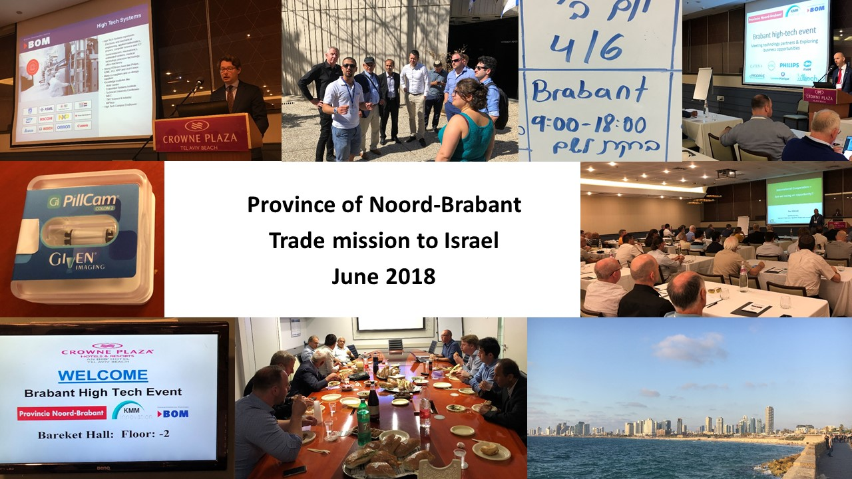

Beyond

Training Facilitator Intervision starts: 31 May 2018
The 'Facilitator Intervision' course aims to train facilitators of intervision. Increasing the quality of facilitators also increases the quality of intervision and thus the effect on the individual and the organization.
During the training, the process of intervision and how this can contribute to the development of individual, team and organization will be discussed. Relevant learning theories are used and linked to the process of intervision.
With case studies from their own work intervision methods are practiced, in which the participants alternately occupy the role of facilitator, participant and case initiator.
Read the Flyer training facilitator intervisie May 2018

AMSystems

3D FOOD PRINTING EXPERIENCE – 29 JUNE
Posted on 6 June 2018 at 10:58.
Written by Hoi-Yan Planjer
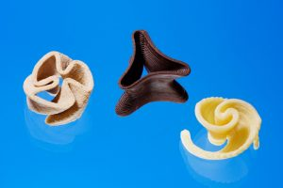
How to meet the demands of more food in the near future?
Join the ‘3D Food Printing Experience’ on June 29 at Wageningen University & Research. And learn more about various 3D printing technologies and state-of-the-art 3D printing equipment.
Click here for the full program and free registration.
The ‘3D Food Printing Experience’ is a collaboration of WUR and AMSYSTEMS Center.

SUCCESFULL AMSYSTEMS CENTER INNOVATION DAY
Posted on 5 June 2018 at 13:23.
Written by Hoi-Yan Planjer
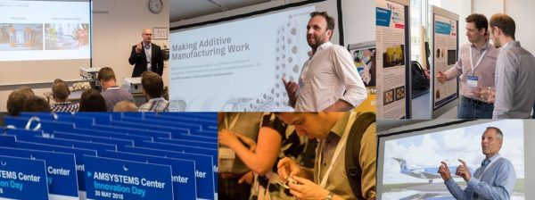

Last Thursday, 30 May 2018, the AMSYSTEMS Center Innovation Day took place at De Gele Kegels, Eindhoven.
This day AMSYSTEMS Center had a rich and varied program. The program consist of interesting talks from international speakers from different industries, such as aerospace, software, pharmaceutical and mechatronics industry. Our innovations in High Tech applications, Printed Electronics, Food and Pharma were shown at our tech market and at our lab facilities. This day our partners, among them also the Fieldlab MultiM-3D partners, and participants shared their developments and view on additive manufacturing. Thanks to them we look back at a successful and varied day.

Click here for the abstracts of the key notes.

Click here for the abstracts of the presentations.
- Click here for an impression of Innovation Day.

Convolo
On March 22 the book "De luie manager" has been published. The book is written in Dutch. To order on for instance managementboek.nl.
A smart manager is lazy. Being lazy requires that you let go things and that you are not too busy, so that you have time left for the things that truly matter. Martin Waaijer aims to inspire managers as well as employees to a new form of cooperation, in which managers use the complete potential of their employees and give back to themselves and their employees the enjoyment in the daily work.
In projects, I often see project managers who are very busy with project plans, technical consultation and reporting, but who pay little attention to human relationships in the project. The project is perceived as a technical problem rather than an issue of cooperation.
We don’t only see this in projects but also in organizations. Managers have a wrong idea about their tasks and therefore spend a lot of time with the wrong activities. The consequence is that there is little time left for the things that truly matter.
I see that managers, for example, spend a lot of time with working meetings with employees and with meetings with other executives to exercise control over the organization. Meanwhile, they read and write voluminous reports. Managers are very busy, but their employees are nevertheless dissatisfied. They complain about the lack of vision of management, the lack of autonomy to practice their craft, the lack of personal trust and the unavailability of managers when they really need them.
What are we doing wrong? I think that we still go too much with the outdated concept of hierarchical structures with many rules and procedures to control the organization. The starting point of many managers is mistrust. They are then surprised that employees don’t take responsibility and show victimization.
In my point of view there is only one solution and that is self-organization. Assume that your employees can think for themselves, are capable and are able to organize their work for themselves. Are you obsolete? No: what they need from you is passion and vision, and the resources and conditions within which they can act autonomously and take responsibility.
The choice of self-organization requires something that managers have hard time with: to let go. Your expectation must be that employees are autonomous professionals who know what they do, who occasionally make mistakes just like you, which they usually solve for themselves and of which they learn. Your expectation must also be that they often do not need you, but will mobilize you if they feel the need. You must suppress your reflexes to intervene at the slightest little thing that is getting to go wrong. You will wonder about the new dynamic that arises: employees who will surprise you positive, unexpected initiatives and original solutions. You can’t even tell anymore how you could function the way things were.
Be lazy and leave the daily work to people who know what they are doing. Stop with holding meetings and controlling employees, in order for you to have time for good personal conversations. Be lazy, so that customers, patients, citizens and students are put back at the centre.
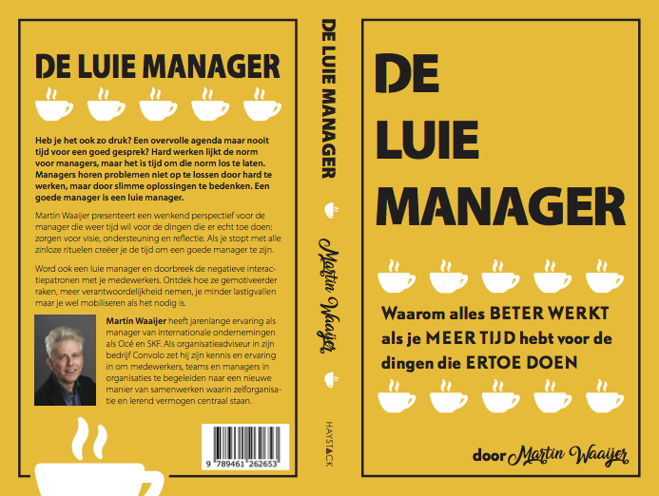

Technion
Agile Focus Strategy for Startups: Oxymoron or Key Success Factor?

A PhD study done at the Technion’s Industrial Engineering and Management Faculty turns into a practical new book for entrepreneurs and innovators, offering a simple framework for setting a promising strategy based on the successes and mistakes of hundreds of startups.
One of the most common pieces of advice for entrepreneurs is to adopt a ‘laser-sharp’ focus approach, wherein they pursue a single narrow market opportunity in order to make the most out of their scarce resources. And because innovation is often fraught with uncertainty, they must also stay flexible and agile so that they can adapt quickly.
Without a doubt, both focus and flexibility are crucial elements for successful startups. But the two are often contradicting. In fact, a narrow sharp focus may lock the company into one specific direction, and actually hinder its agility. So how, if at all, can entrepreneurs manage this delicate balance?
Dr. Sharon Tal – a marketing lecturer and the former manager of the Technion Entrepreneurship Center – saw startups dealing with this dilemma over and over again when mentoring budding entrepreneurs at the center. Intrigued by this question, her PhD study examined the early strategic choices of startups. In an in-depth research, she interviewed technology entrepreneurs to understand how they choose their market focus and how they manage the trade-off between focus and flexibility.
Her study found that 72% of the companies changed their market focus within the first three years, which illustrates the importance of startups not sacrificing their agility for the sake of sharper focus. In fact, firms that were able to manage both turned out to be the most successful startups in her sample. These companies consciously strived to avoid locking in by keeping a few related market opportunities open. Acknowledging these future options helped them develop their resources and capabilities in a more general manner. It also made their firm more robust to change, without compromising the pursuit of their most promising opportunity. Sharon and her research colleague Prof. Marc Gruber (EPFL, Switzerland) termed this the Agile Focus Strategy.
The researchers say that companies of any size and stage – from small startups to large enterprises – can embrace this strategic reasoning and adopt an Agile Focus Strategy. They also say it can be accomplished in three clear steps:
- Identify additional market opportunities that could be suitable as your backup or growth options. A backup option is one you will want to pursue if you are not successful with your current opportunity. A growth option is a market opportunity you will want to pursue once you are successful with your current opportunity.
- Evaluate the relatedness of these possible options to the market opportunity you are focusing on. Relatedness means that the ability to develop and deliver the product – for both markets – requires relatively similar resources and capabilities. The more related an option is, the more you can leverage your existing competencies to succeed in it. And this is exactly what we want.
- Pick at least one backup and one growth option to keep open. Keeping an option open means that you invest very few resources and management attention only to monitor it and to make sure not to lock yourself out of this path. So, when you develop your venture’s unique abilities, resources and networks, you keep these options in mind. This is exactly what will keep you flexible and nimble over time.
To help entrepreneurs and innovators design their market opportunity strategy, Sharon and Marc recently launched a new book – Where to Play (Pearson Financial Times). In it, they present a visual, easy-to-apply framework for identifying, evaluating and strategizing market opportunities, in order to get the most value for your innovation. This proven method is based on the successes and mistakes of hundreds of startups. It nicely complements other well-known business tools, including the Business Model Canvas and the Lean Startup Methodology.
In fact, in a recent course done at the MBA program of the Technion, students applied this framework on Technion related inventions with great success. One of the key take aways from this course was that startups can make informed strategic choices that keep them both focused and agile. Without being open to alternative paths while concentrating limited available resources, and without the ability to efficiently handle change or adaptation, they may simply lose the race.

Wearable Devices for Early Disease Monitoring and Diagnosis
HAIFA, ISRAEL and NEW YORK (May 17, 2018) – Researchers from the Wolfson Faculty of Chemical Engineering at the Technion-Israel Institute of Technology have developed an integrated system for early diagnosis of diseases using wearable monitors. Able to continuously monitor physiological indicators without disturbing the user, the system can repair itself in the event of a tear or scratch, and receives the energy required for operation from the wearer.
This could help spare patients much pain and suffering, greatly reduce medical expenses, and provide extensive and detailed information for epidemiological studies. The system was presented in a review paper published in Advanced Materials by Technion Professor Hossam Haick and postdoctoral researcher Dr. Weiwei Wu (who is now a professor at Xidian University in China).
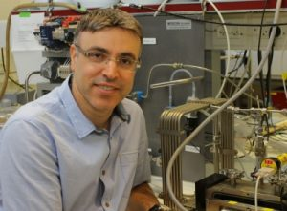
Professor Hossam Haick

Wearable devices for medical monitoring are gaining momentum, because they provide a convenient and inexpensive platform for the continuous collection of medical information without the need for invasive procedures. Such devices enable early disease
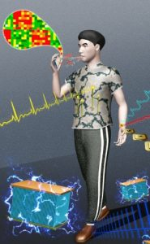
A demonstration of the system that monitors heart rate, peripheral nervous system activity, and other physiological markers, and transfers the data to the cloud where they are available to qualified individuals for analysis and medical recommendations.
monitoring, before outbreaks, and earlier and more efficient treatment. They can be attached to shirts, jewelry, sweatshirts, watches, shoes, and glasses, and allow the user to go about his or her day without interruption. As a result, such devices are expected to encourage people to be proactive about their health and to reduce avoidance of medical examinations.
“Normal health is characterized by known markers such as 60 to 100 heart beats per minute and 7 to 8 breaths per minute,” said Prof. Haick. “If we detect dramatic changes in the various markers in real time, we can refer the patient to a more comprehensive diagnosis and prevent disease from developing or worsening.”
The system developed at the Technion contains sensors and tools that process the data and transmit it to the authorized medical authority. It combines a series of innovative elements that provide unprecedented monitoring capability:
- A combination of precise sensing and advanced analysis tools
- The energy it requires for operation is derived from the wearer’s body (movements and body heat)
- The device is made of advanced self-healing materials in case of a scratch or cut
The energy derivation and self-repair give the new device a long lifespan, and prevent the need to turn off the system for repair or charging. “This system will not just continuously monitor physiological markers in the wearer. It also aid the long-term collection of extensive information that may be used for epidemiological studies,” said Prof. Haick.
Although the system’s components already exist, a platform that integrates them all has not yet been developed. It requires a complex array of sensors, a tiny and flexible circuit board for measuring the markers, and components that process the information and transfer it to the cloud. All of these are being implemented in the new system being developed by Prof. Haick’s research group.
About the researchers

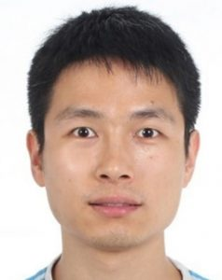
Postdoctoral researcher Dr. Weiwei Wu
Prof. Hossam Haick is a faculty member at the Wolfson Faculty of Chemical Engineering at Technion and a member of the Russell Berrie Nanotechnology Institute (RBNI). He has been recognized primarily due to developing an innovative, non-invasive system for medical diagnosis based on breath. Prof. Haick heads the SNIFFPHONE consortium, which integrates this system into a cellphone so that the data will be uploaded to the cloud for analysis by qualified medical personnel. In 2016, Prof. Haick published an international study in the scientific journal ACS Nano, which examined the unique diagnostic technology he had developed. The study involved 1,404 patients from 5 countries and confirmed the value of the technology for the early diagnosis of 17 different diseases: lung cancer, bowel cancer, head and neck cancer, ovarian cancer, bladder cancer, prostate cancer, kidney cancer, gastric cancer, Crohn’s disease, ulcerative colitis, irritable bowel syndrome, Parkinson’s (two types), multiple sclerosis, pulmonary hypertension, preeclampsia, and chronic kidney disease. The system diagnoses these diseases with an accuracy of 86% on average.
Dr. Weiwei Wu completed his undergraduate degree in chemistry and a doctorate in physics and materials chemistry at Lanzhou University in China. The present study was conducted while he was a post-doctoral researcher under the direction of Prof. Haick. He is currently a professor at the School of Advanced Materials and Nanotechnology at Xidian University in China.
Click here to the paper in Advanced Materials

Scent Academy
Cinquième Sens Northern Europe (a subsidiary of Scent Academy for the Benelux and Norther Europe) has organized at their headquarters in Amsterdam an event with award winning best barmen of the world, exploring the links between scent, flavours and cocktails. The current trend of either using perfumes to invent cocktails or personalising the aroma sphere of drinks is a strong line of innovation with leading examples in London, Paris, Singapore and Berlin.
Re-inventing the cocktail experience by using fragrances is the new trend for top performers: Creating and interpreting fragrance notes and ingredients leads to a personal and original artistic signature. While the collaboration between scents, fashion and beauty are well established, the collaboration between perfumers and cocktail is a powerful novel approach gathering momentum.

AULIVE

AULIVE methodology
AULIVE is rooted in existing methodologies such as TRIZ, QFD and the theory of constraints. The basis of this method is product DNA®, which describes materials, products and processes as a combination of property-function relations.
Based on this relation there are two options:
- Find and implement solutions borrowed from other domains and industries.
- Vary the existing properties of a product, process or material to increase its value

Integrate-research

Nobleo

AUTONOMOUS HARBOUR CLEANING
For customer Ranmarine, we developed the localization and navigation hardware and software for an Aquadrone. RanMarine is a Dutch environmental technology enterprise, building drones that remove waste from the water and support the natural resilience of our oceans. These fully autonomous drones swim through the water, collecting waste and other non-biodegradables, whilst gathering data about the environment.
Specifications:
- Autonomous sailing though Ports and Harbours to collect waste on the water-surface
- Data acquisition on the water-surface
- Usage of marine charts in an end-user GUI
- Re-planning capabilities in case of obstructions on the global path
- Able to anticipate other vessel trajectories and able to sail around them
Docking system for getting drones in- and out of the water, for charging batteries and removing collected waste.

